AI Lab 5 Task 1
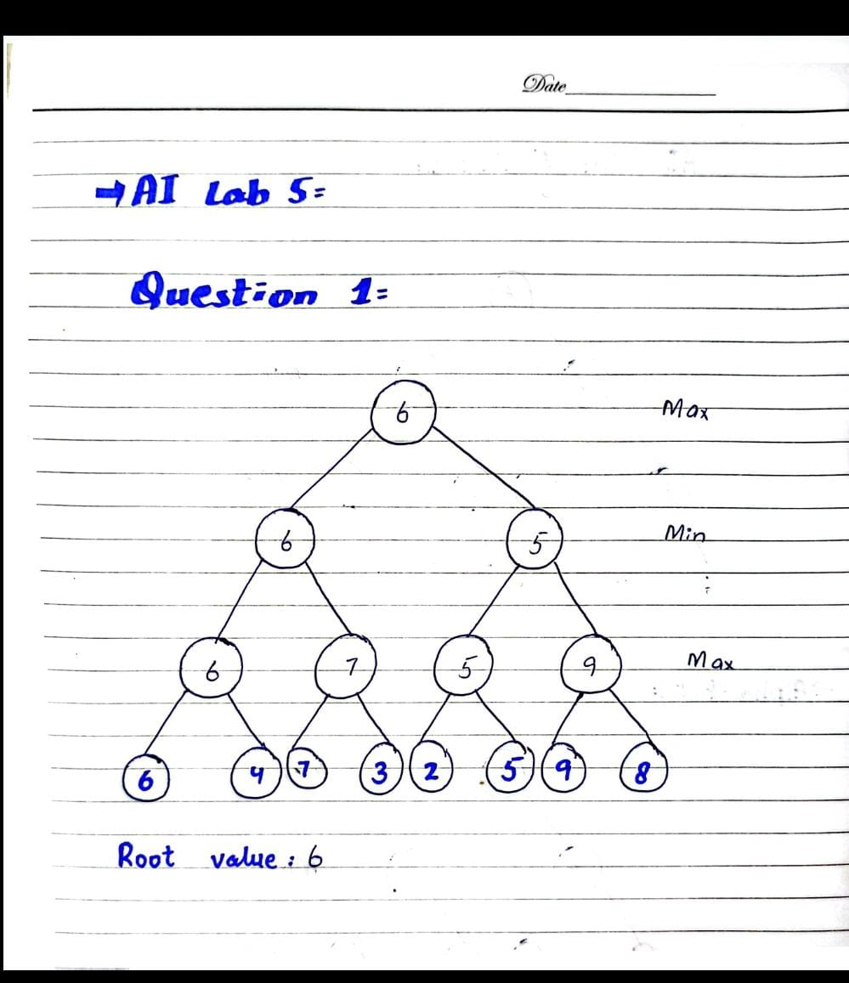

- Code Output:
